IT24100966

Lab 9

Kaluarachchige P.E.K

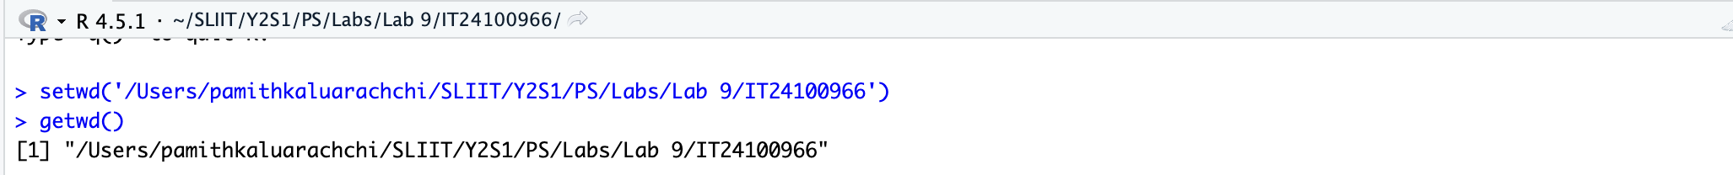

1. Assume that the time taken to bake a batch of cookies is normally distributed with mean 45 minutes and standard deviation 2 minutes.

I. Generate a random sample of size 25 for the baking time.

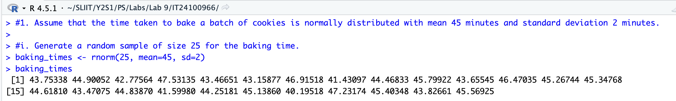

ii. Test whether the average baking time is less than 46 minutes at a 5% level of significance.

